The Raven Tweets Activity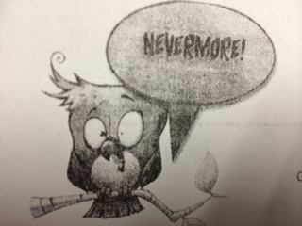

Translate “The Raven” into Tweets on Twitter. Twitter limits users to 140
characters and uses hashtags # to note key ideas or tie into trends.

Convey nearly all of the events of your stanza into your tweet, though it may be condensed. Don’t change the plot, introduce new characters, etc. #Havefun

Stanza 1 - The narrator hears a knocking at his door. #raven #chamber

Stanza 2 - It’s cold, the fire is burning, and I can’t wait til tomorrow. The sadness is real #depressed

Stanza 3 -The narrator was terrified, and went to his chamber door. #BRB

Stanza 4 -The narrator was terrified, and went to his chamber door. #terror

Stanza 5 -I stood there wondering; fearing, and the only whispered word spoken, ‘Lenore’. #Lonely

Stanza 6 -Just heard more tapping, probably nothing. #JustTheWindraven
Stanza 7 - Flung a shutter, a raven came & went on chamber door on top of a bust of Pallas, the goddess of Wisdom

Stanza 8 -I called upon the raven and asked it’s name and the raven answered ‘Nevermore’ #wisebird

Stanza 9 -The narrator thinks no one else has had a bird on his chamber door named nevermore. #nevermore

Stanza 10 -The raven landed on the shoulder of a peaceful statue and only said one word from it's soul deep down "Nevermore" #creepytalkingbird

Stanza 11 -The narrator thinks the bird only learned the word nevermore #nevermore

Stanza 12 - The narrator sits in front of the bird, trying to figure out what he’s saying. #birdwhisperer

Stanza 13 -The narrator sat down and began to think, then anger approached him and he began to think some more. #anger! :||

Stanza 14 - I want something to forget Lenore, the raven said no. #whynot

Stanza 15 -Where did this raven come from #stalker much

Stanza 16 - Does heaven have my Lenore? #angels

Stanza 17 -Yells at the raven to leave the chamber #cray cray

Stanza 18 - The Raven is sitting on the bust of Pallas. #The horror is real
#allusion

