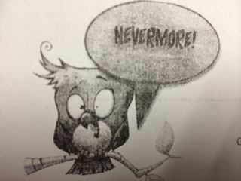
Translate “The Raven” into Tweets on Twitter. Twitter limits users to 140
characters and uses hashtags # to note key ideas or tie into trends.

Convey nearly all of the events of your stanza into your tweet, though it may be condensed. Don’t change the plot, introduce new characters, etc. #Havefun

Stanza 1 - I was about to fall asleep until someone came knocking at my door #whodat

Stanza 2 - In my chamber, hoping to drown out the painful thoughts of Lenore with a book # RIPLenore

Stanza 3 -Terrified by creepy sounds trying to reassure myself #heartbeatingfast

Stanza 4 -I was taking a good nap when there was a loud tapping noise at my chamber door. I opened it but there was nothing there. #bestalarmsystemever

Stanza 5 -Starring into darkness, darkness whispers lenore, i whisper back
#Hearing things

Stanza 6 - Tapping at the window now! #Hearing things

Stanza 7 -A random raven just flew in through my window he looks confident perched upon Athena`s head. #intruder

Stanza 8 - Asked raven his name is in the Underworld #Nevermore #spooky

Stanza 9 - Wondering about the ugly raven's cawing, being the only human blessed by him above my door. #feelingspecial

Stanza 10 - The only thing the Raven says is “Nevermore” but the Raven will leave just like Lenore did. #everybodyhatesme

Stanza 11 - Thanks to the owner sad songs are all it hears and all it knows #brokenrecord

Stanza 12 - Creepy raven at my door - wheel my chair over bird said ‘Nevermore’ #thinkingtoomuch

Stanza 13 -he sat there thinking quietly and I know it was about Lenore #awkwardsilence

Stanza 14 - Angels sent creepy raven to help forget Lenore! He says I won’t forget her. don’t #don’tlethergo

Stanza 15 - Idk(I don’t know) where this bird came from #goincraycray

Stanza 16 -he does not know where a raven came from thinks its a prophet. #crazy

Stanza 17 -go back wherever you came from.#birdbackoff

Stanza 18 -the raven won't leave... I guess my sorrow is here forever #ihatemylife

