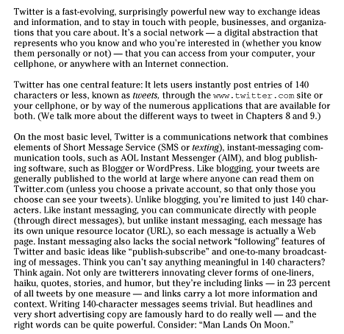

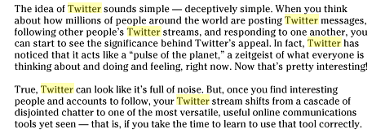

Source: Twitter Is for Dummies 2nd Edition by Laura Fitton, Michael E. Gruen, Leslie Poston

Wiley Publishing, Inc.. 111 River St., Hoboken, NJ 07030, 2010

